**Testing Concepts**

Lesson 02 : Types of testing techniques & test case design

Verification and Validation

Verification refers to a set of activities which ensures that software correctly implements a specific function. Purpose of verification is to check: Are we building the product right?

Validation refers to a different set of activities which ensures that the software that has been built is traceable to customer requirements. Purpose of Validation is to check : Are we building the right product?

Types of Testing Techniques

**Static Testing**

It is a verification process. Testing a software without execution on a computer. Involves just examination/review and evaluation.It is done to test that software confirms to its SRS i.e. user specified requirements. It is done for preventing the defects

**Dynamic Testing**

It is a validation process. Testing software through executing it. It is done to test that software does what the user really requires It is done for detecting the defects

Static & Dynamic Testing Techniques:



Introduction to Static Testing Techniques:

Static Testing Methods - Self Review , Code Inspection, Walk Through, Desk Checking (Peer Review)

Static Testing Techniques – Defects Detected & Benefits

**Types of defects found during static reviews:**

Deviations from standard, Requirement defects, Design defects, Insufficient maintainability, Incorrect interface specification  
**Benefits of Reviews:**

Early feedback on quality, Development productivity improvement, Reduced development timescales, Reduced testing time and cost, Lifetime cost reductions

Review Process Success Criteria

**Success factors for reviews:**

Review should be with clear objective, Defects found are welcomed and expressed objectively, Management supports a good review process, The emphasize is on learning and process improvement, The right people for review are involved

Introduction to Dynamic Testing:

Dynamic Testing involves working with the software, giving input values and validating the output with the expected outcome. Dynamic Testing is performed by executing the code.It checks for functional behavior of software system , memory/CPU usage and overall performance of the system

Types of Dynamic Testing Techniques

**White Box Test Techniques**

* + Code Coverage
    - Statement Coverage
    - Decision Coverage
    - Condition Coverage
    - Loop Testing
  + Code complexity
    - Cyclomatic Complexity
  + Memory Leakage

**Black Box Test Techniques**

* + Equivalence Partitioning
  + Boundary Value Analysis
  + Use Case / UML
  + Error Guessing
  + Cause-Effect Graphing
  + State Transition Testing

Test Case:

Test Case is a set of inputs, execution preconditions, and expected outcomes developed for a particular objective, such as to exercise a particular program path or to verify compliance with a specific requirement.

Test Case Life Cycle:

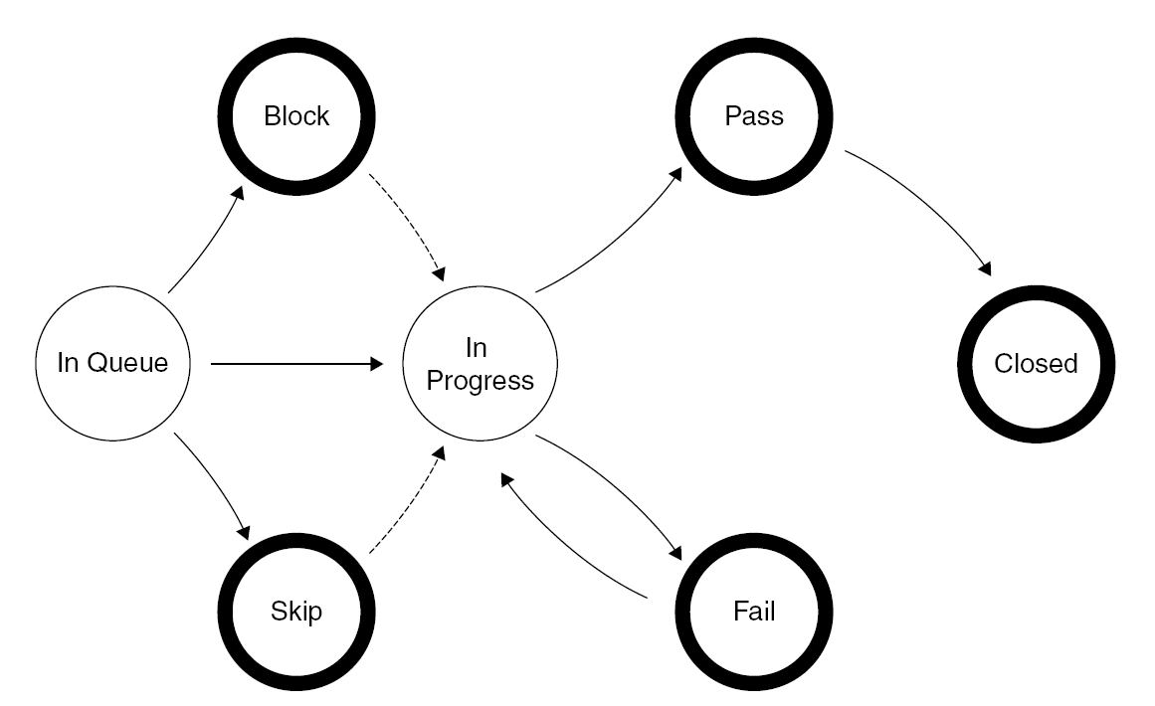

Test Data:

An application is built for a business purpose. We input data and there is a corresponding output. While an application is being tested we need to use dummy data to simulate the business workflows. This is called test data.

Positive & Negative Testing:

Positive testing can be performed on the system by entering the valid data as input. The purpose of Negative testing is to break the system and to verify the application response for invalid inputs

Basic Test & Alternate Test:

Basic tests are used to test very basic functionality of software. Sometimes there maybe more than one way of performing a particular function or task with an intent to give the end user more flexibility or for general product consistency. This is called alternate testing